MATHEMATICAL FOUNDATIONS LAB TEST – CA1

S VARUN 21PC26

18/11/2021

1. A)

Plot sin(x) on the interval [-2pi, 2pi] using 0.01 spacing. Plot the function with a solid line and the derivative with a dashed line. Add a legend and label the axes and determine how many times their graph intersect.

PROGRAM CODE:

x = [-2*pi : 0.01 : 2*pi];

y = sin(x);

y_derivative = cos(x);

plot(x, y, '-b');

hold on;

plot(x, y_derivative, '--r');

title('Graph Of Sin(x) And Its Derivative Using Matlab CA1 1a')

xlabel('x - axis'); ylabel('y - axis');

legend('f(x) = sin(x)',"f'(x) = cos(x)");

OUTPUT:

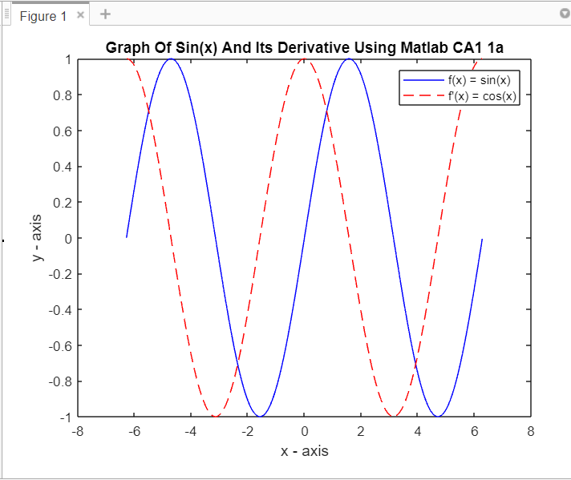

1. B)

Create the following matrix   
X = [2 4 6 8 10

3 6 9 12 15

7 14 21 28 35]

PROGRAM CODE :

X = [2:2:10; 3:3:15; 7:7:35];

X1 = X(2,:);

X2 = X(:, 4);

First_Row = X(1, :);

Second_Row = X(2, :);

X3 = [First_Row Second_Row];

Second_Column = X(: ,2);

Fifth_Column = X(:, 5);

X4 = [Second_Column; Fifth_Column];

First_Column = X(: ,1);

Third_Column = X(: ,3);

Fourth_Column = X(: ,4);

X5 = [First_Column, Third_Column, Fourth_Column];

disp(X);

disp(X1);

disp(X2);

disp(X3);

disp(X4);

disp(X5);

OUTPUT:

